How to write a value to a Modbus device in PecStar

1. Start PecConfig
2. Add a site, select the Driver Type “**MODBUS Protocol Master Site Driver**”.

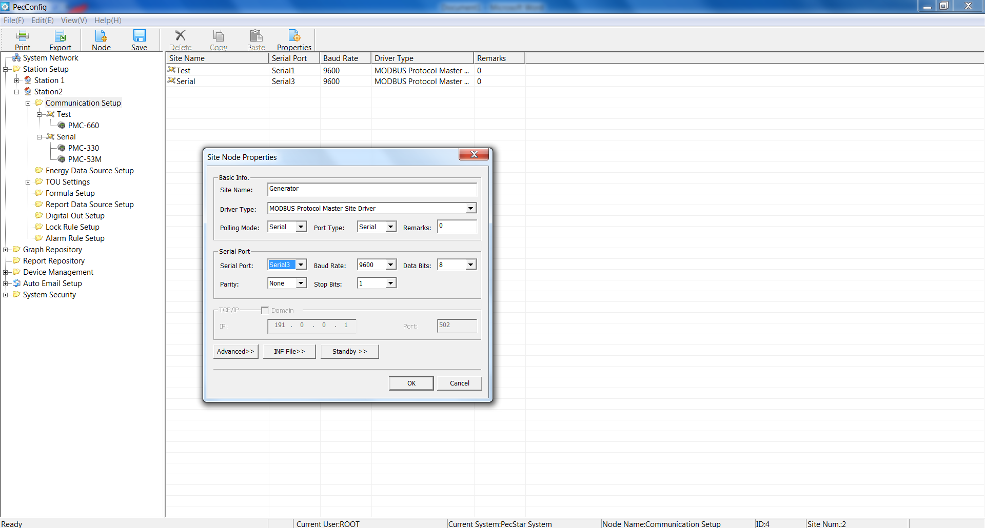

1. Add a device, select the Device Type “**ModbusMeter**”.

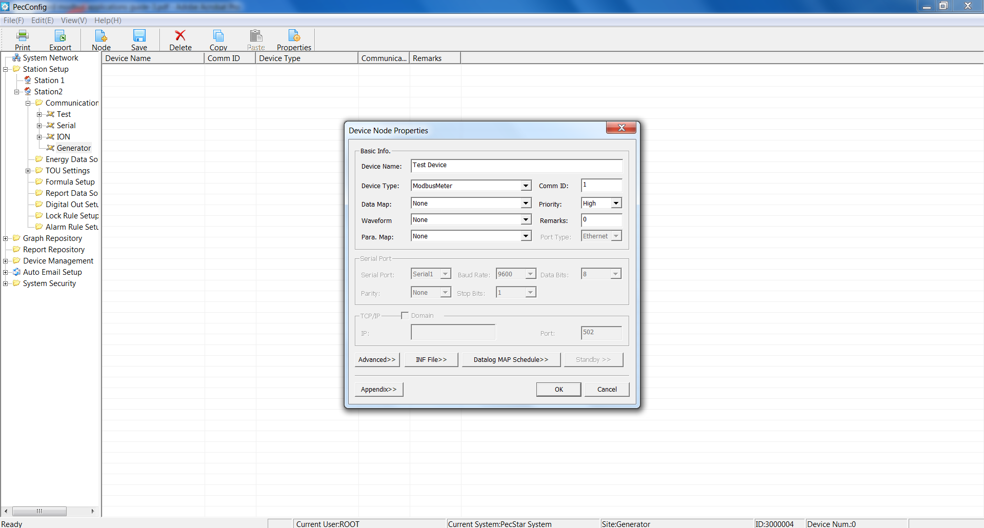

1. Click **Appendix>>** on the Device Node Properties window, the following window appears.

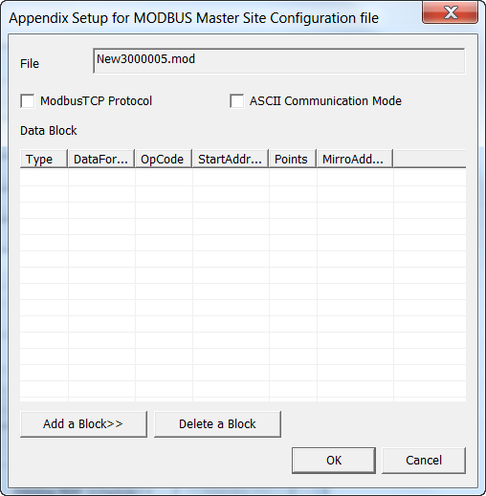

1. Click **Add a Block>>**, setup the Modbus Block in the pop-up window. For example, to write to the register 302, enter the settings as below:

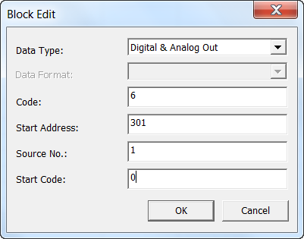

Click OK.

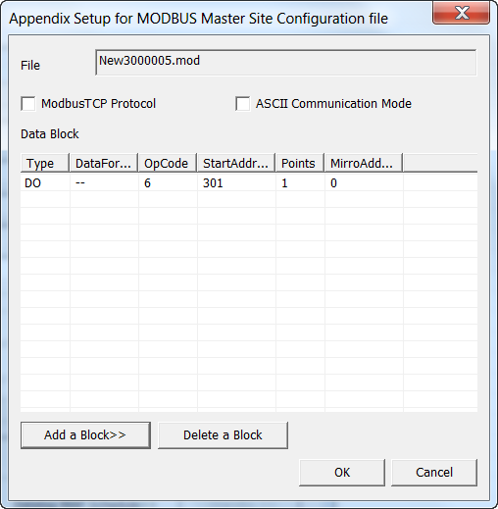

1. Right-click on **Digital Out Setup** and select **New…**. The Digital Out Properties window appears. Enter the settings as below:

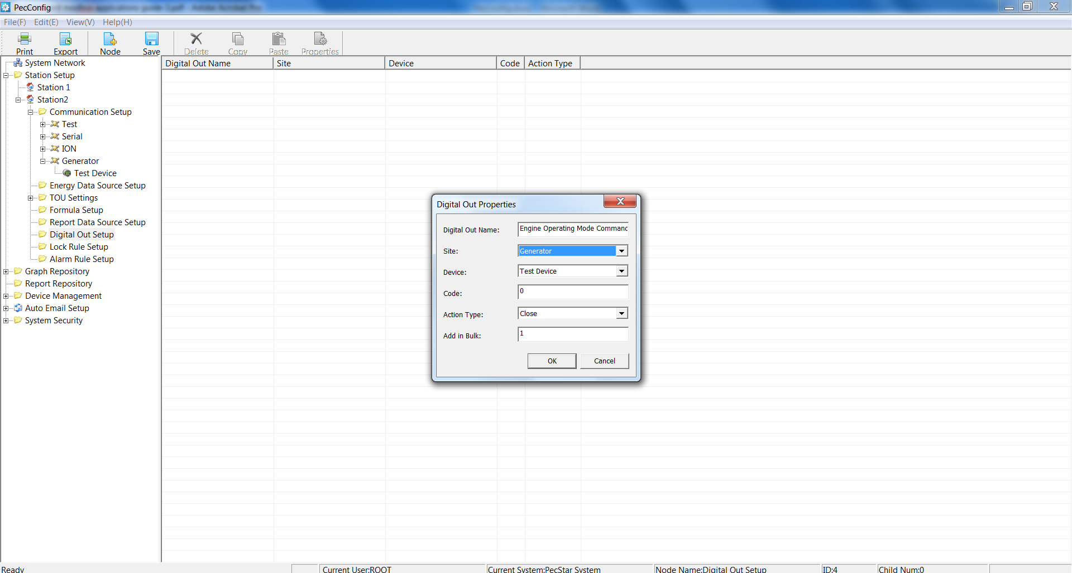

The **Code** in this window must be the same as the **Start Code** in step 4).

1. The defined Digital Out is listed in the right-pane.

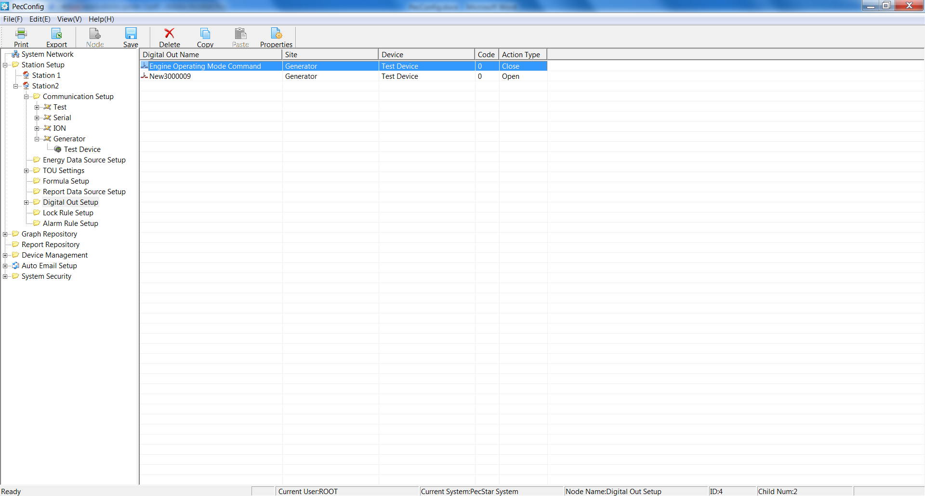

1. Save the configuration to database.
2. Start DServer.
3. Start PecSCADA.

The **Digital Out Sources** are shown as below.

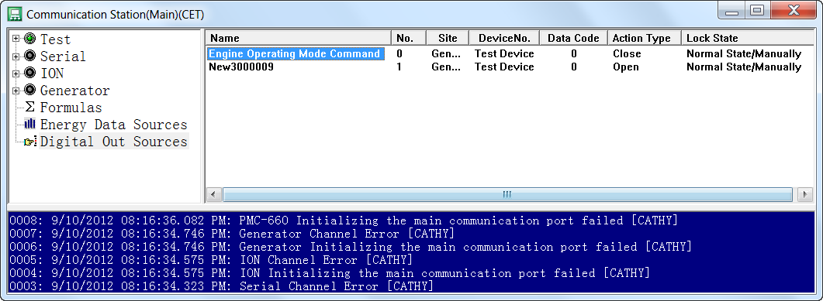

1. Start PecDraw.
2. Click **New…** to create a new **Common Graph File**.

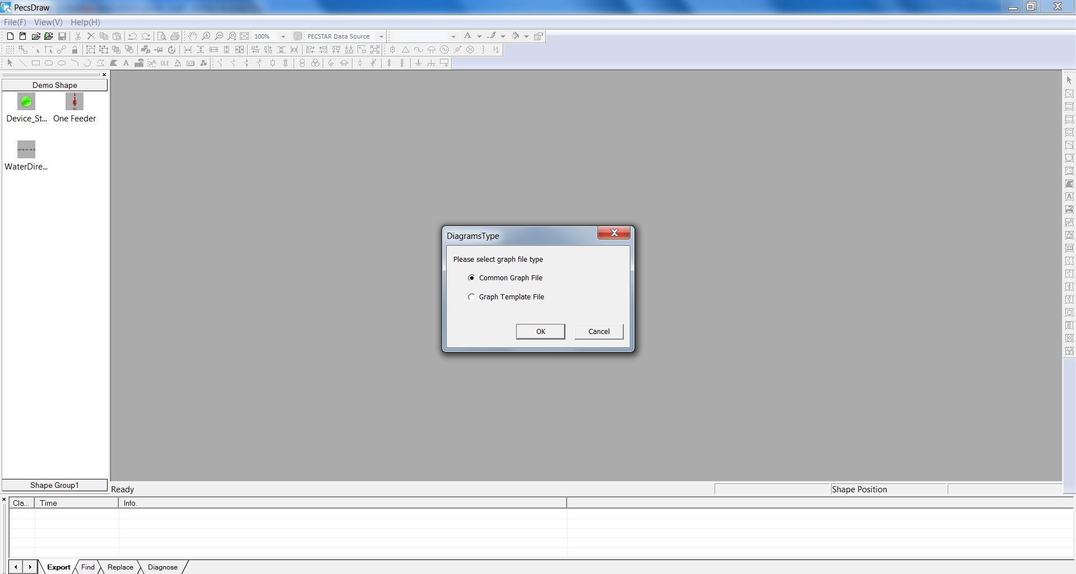

1. Draw a Button. In the Properties windows, click the **Mouse Left Click** tab, select **Remote Regulating**, the **Analog Out List** dialog box appears.

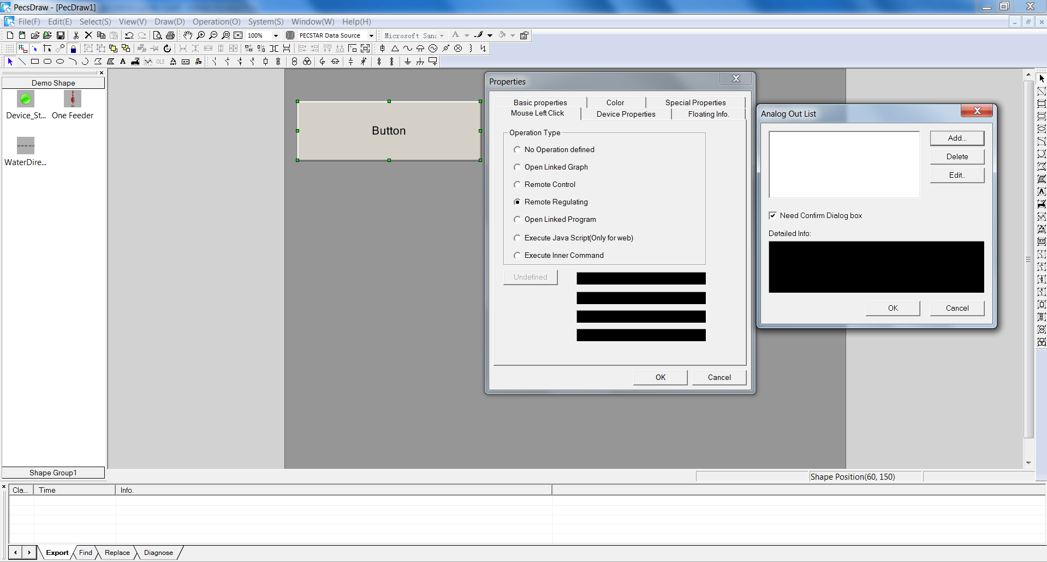

1. Click **Add…**, enter the settings as below:

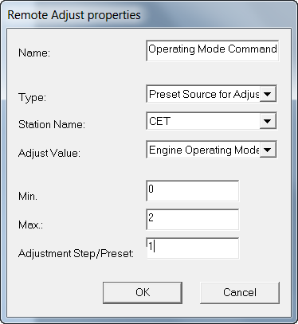

1. Save the .drw file.
2. Start PecView.
3. Navigate to the .drw file. Move the mouse to the Button and click.

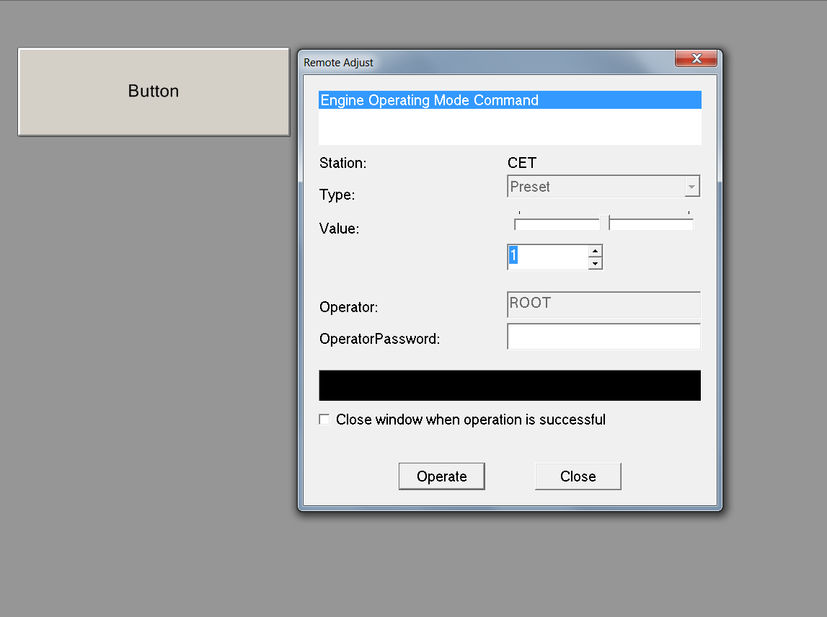

1. The Remote Adjust window appears. Click the **Up/Down** arrow below **Value** to change it and then Click **Operate**.
2. Click **Ok** to make sure to send the command and execute.

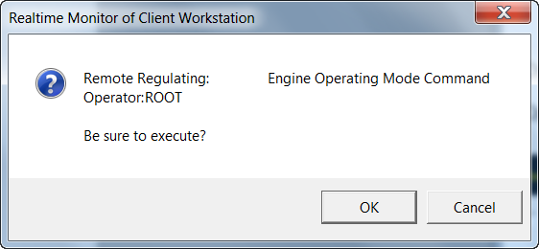

1. After the command is executed, a message will appear in the black area.

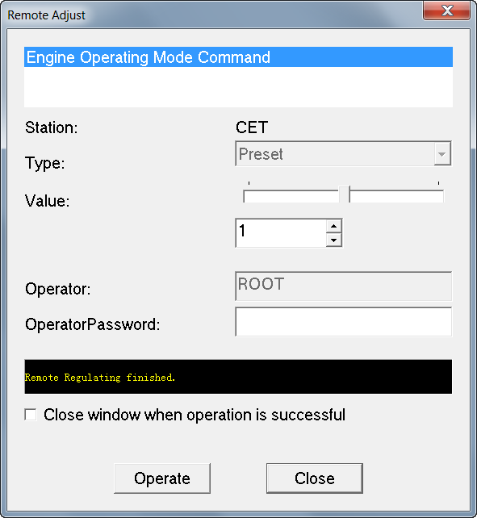

1. View the **Digital Out Source** value from the PecSCADA to check if the command is performed successfully.